

JADAVPUR UNIVERSITY

Department of Electronics and Tele-Communication Engineering

Faculty of Engineering and Technology

Digital Circuits-I Lab Assignment 9

UG-II SEMESTER-III GROUP-10

SUBMITTER NAME : SAIKAT NASKAR

ROLL NUMBER : 302110701003

GROUP MEMBER :

|  |  |  |
| --- | --- | --- |
| S.No. | Name of Student | Roll Number |
| 1. | SAIKAT NASKAR | 302110701003 |
| 2. | ANKIT DAS | 302110701004 |
| 3. | SAMUDRA SARMA | 302110701005 |

Dated- 01.12.2021

# Objective:

**Lab Assignment – 9**

Buffers and Registers

* Realize a 3-bit buffer register using D flip-flops.
* Realize a 3-bit shift register using D flip-flops.
* Realize a 3-bit ring counter using D flip-flops.
* Realize a 3-bit switch tail ring counter using D flip-flops.

# Theory:

1. **IC 7474**: belongs to dual D-type positive edge triggered flip flops, with Preset, clear and complementary outputs. The information on the D input is accepted by the flip-flops on the positive going edge of the clock pulse. Triggering occurs at a voltage level and is not directly related to the transition time of the rising edge of the clock. Data on the D input may be changed while the clock is LOW or HIGH without affecting the outputs as long as the data setup and hold times are not violated. A LOW logic level on the preset or clear inputs will set or reset the outputs regardless of the logic levels of the other inputs. The IC 7474 D flip-flop is known as a “data” or “delay” flip-flop. D-input can be captured by it at a definite portion of the clock cycle. That captured value becomes the Q output. The D flip-flop can be viewed as a memory cell, a zero- order hold, or a delay line.

# Dual D Flip Flop with Preset and Clear

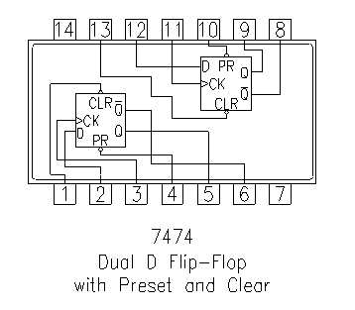

1. Synchronous circuit is a digital circuit in which the changes in the state of memory elements are synchronized by a clock signal. In a sequential digital logic circuit, data is stored in memory devices called flip-flops or latches.

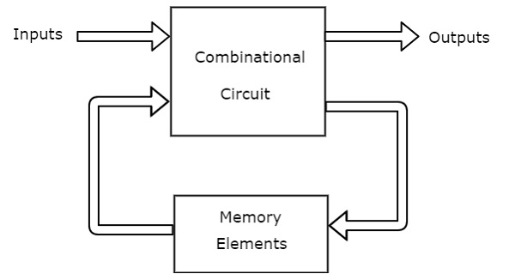

1. **Register:** Flip-flop is a 1- bit memory cell which can be used for storing the digital data. We have to use a group of flip-flops to increase the storage capacity in terms of number of bits. Such a group of flip-flops is known as a Register.
2. **Buffer Registers**: are a type of registers used to store a binary word. These can be constructed using a series of flip-flops as each flip-flop can store a single bit. In order to store an n-bit binary word one should design an array of n flip-flops.
3. **Shift Registers**: is a group of flip flops used to store multiple bits of data. The bits stored in such registers can be made to move within the registers and in/out of the registers by applying clock pulses. An n-bit shift register can be formed by connecting n flip-flops where each flip flop stores a single bit of data.
4. **A Ring Counter**, also known as a “One-Hot Counter” is a type of counter composed of flip-flops connected into a shift register, with the output of the last flip-flop fed to the input of the first, making a "circular" or "ring" structure.
5. **Switch tail ring counter**: The Johnson Ring Counter or “Twisted Ring Counters” or “Switch tail ring counter”, is another shift register with feedback exactly the same as the standard Ring Counter above, except that this time the inverted output Q of the last flip-flop is now connected back to the input D of the first flip-flop as shown below. The main advantage of this type of ring counter is that it only needs half the number of flip-flops compared to the standard ring counter then it’s modulo number is halved.

# 1. 3-bit buffer register using D flip-flops:

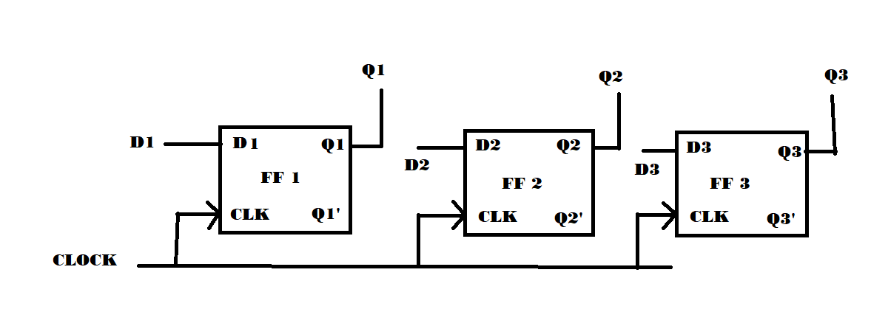

Logic Diagram

Circuit for 3 Bit Buffer Register

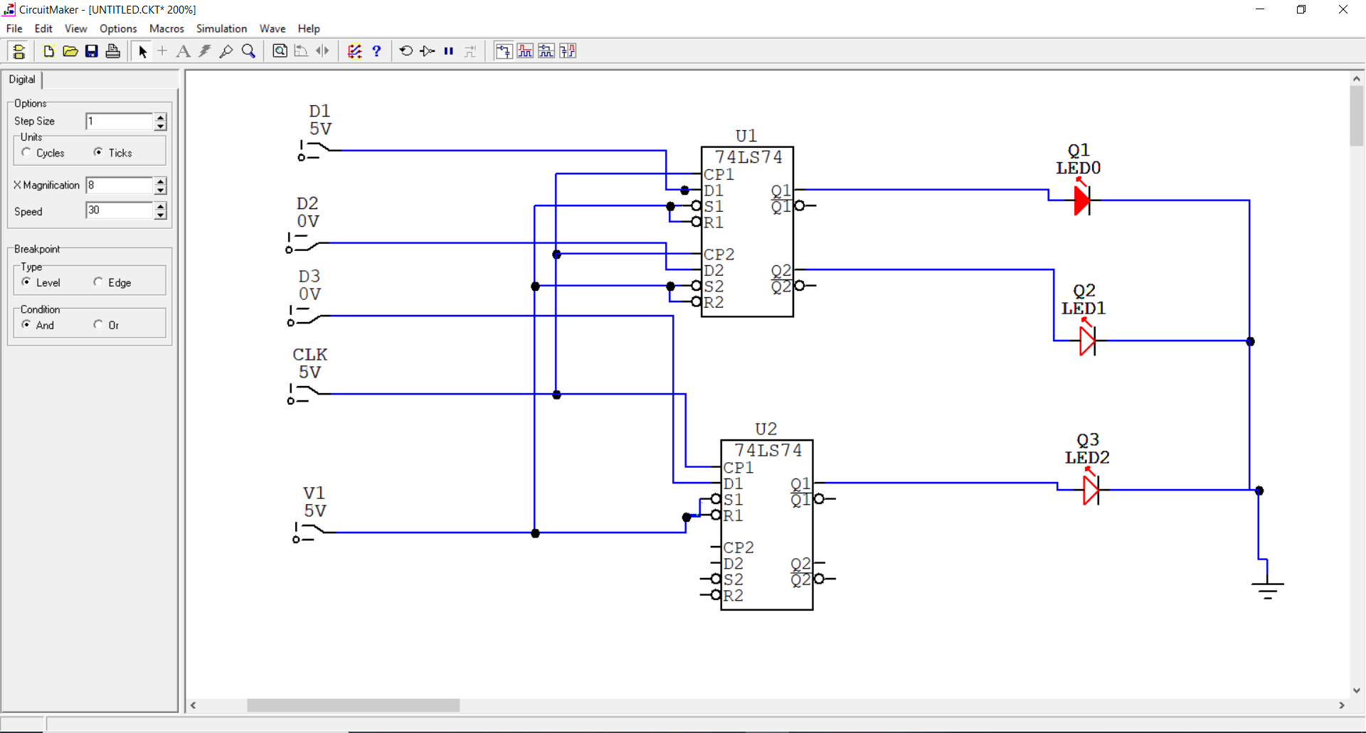

## 2. 3-bit shift register using D flip-flops :

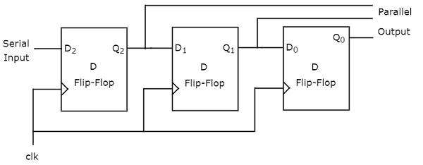

Logic Diagram

Circuit for 3 Bit Shift Register

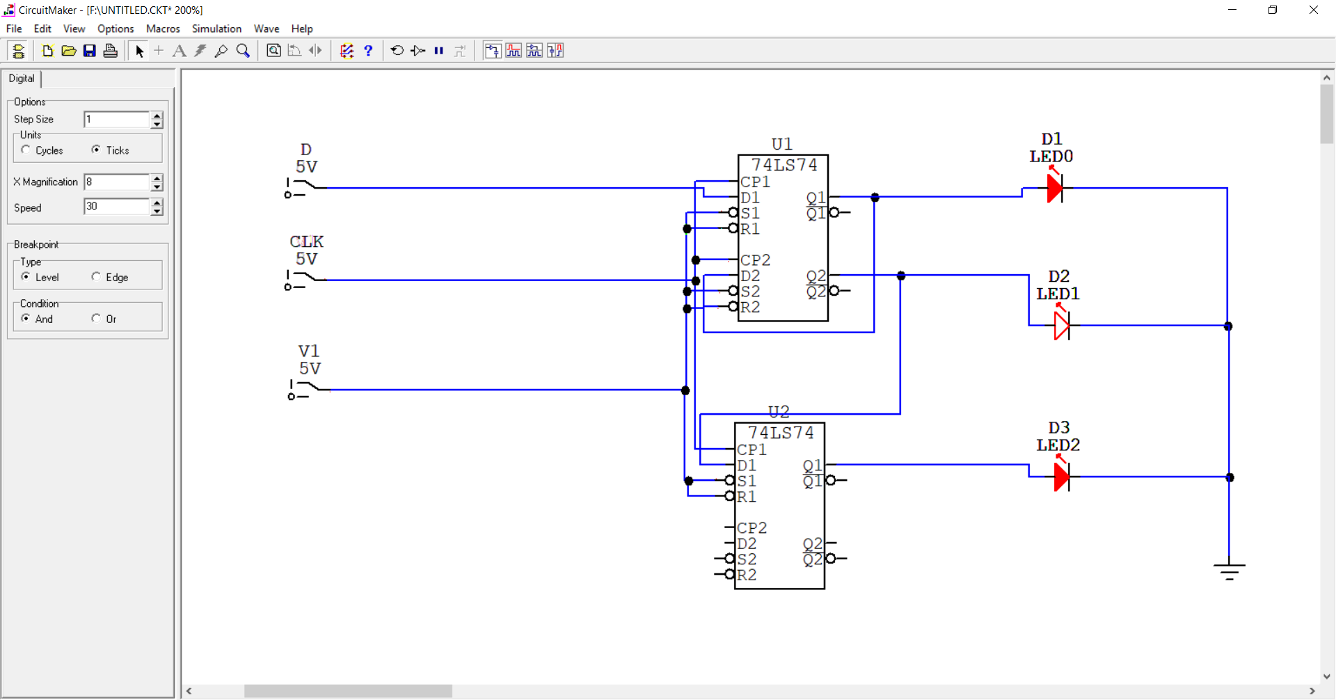

## 3. 3-bit ring counter using D flip-flops :

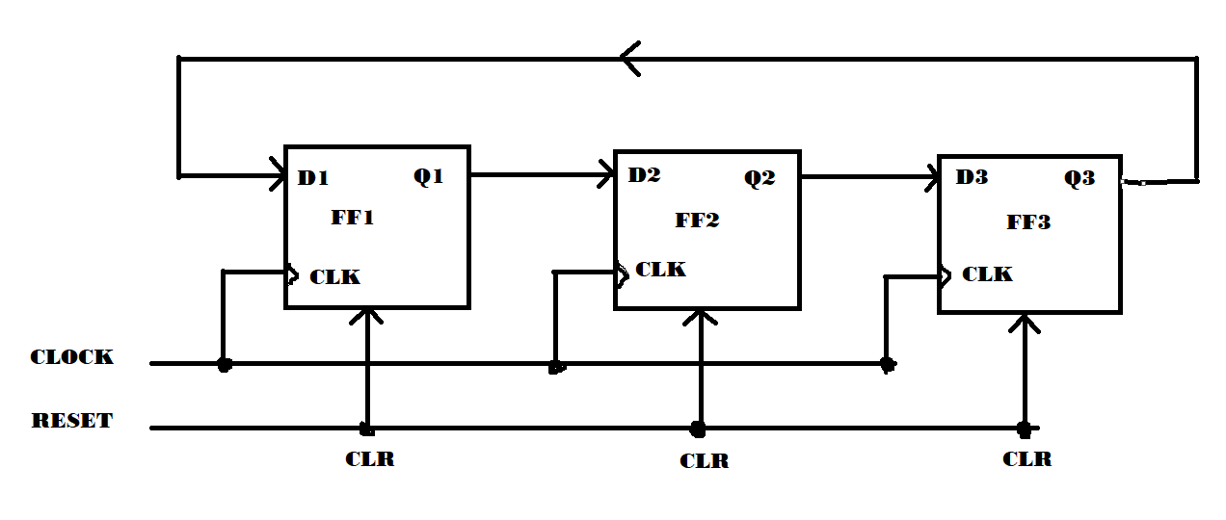

Logic Diagram

Circuit Diagram for 3 bit Ring counter

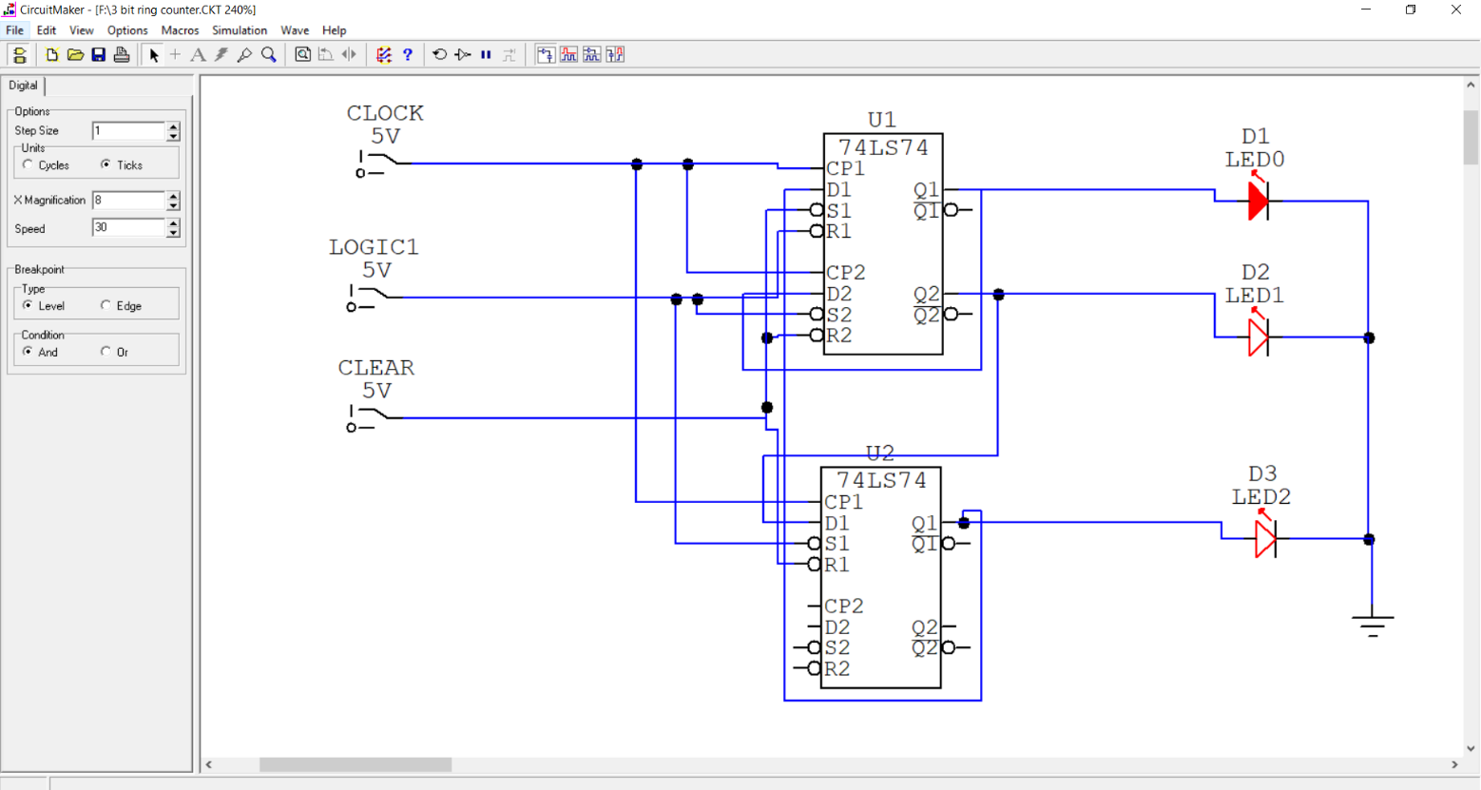

|  |  |  |  |  |
| --- | --- | --- | --- | --- |
| ORI | CLK | Q0 | Q1 | Q2 |
| LOW | X | 1 | 0 | 0 |
| HIGH | EDGE | 0 | 1 | 0 |
| HIGH | EDGE | 0 | 0 | 1 |
| HIGH | EDGE | 1 | 0 | 0 |

Truth Table for 3 Bit Ring Counter

## 4. 3-bit switch tail ring counter using D flip-flops :

## 

Logic Diagram

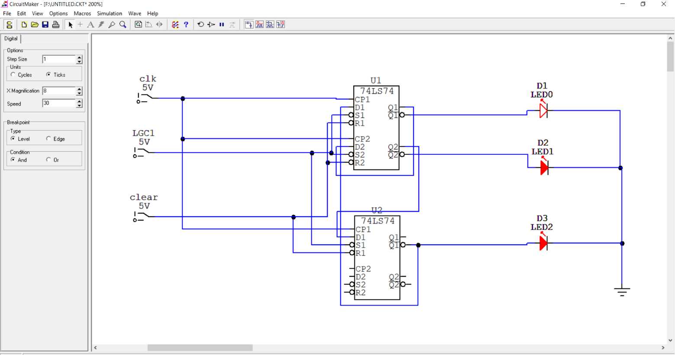

Circuit for 3 Bit Switch Tail Ring Counter

|  |  |  |  |  |
| --- | --- | --- | --- | --- |
| ORI | CLK | Q1 | Q2 | Q3 |
| LOW | X | 0 | 0 | 0 |
| HIGH | EDGE | 1 | 0 | 0 |
| HIGH | EDGE | 1 | 1 | 0 |
| HIGH | EDGE | 1 | 1 | 1 |
| HIGH | EDGE | 0 | 1 | 1 |
| HIGH | EDGE | 0 | 0 | 1 |
| HIGH | EDGE | 0 | 0 | 0 |

Truth Table for 3 Bit Switch Tail Ring Counter

# Conclusion:

* When the Clock changes from 1 to 0, in Buffer Register, there is no change in the outputs, but when the Clock is changed from 0 to 1, the output changes.
* An n-bit ring counter’s capability lies in the fact that it can count maximum up to n distinct clock pulses. For example, 3 bit ring counter can count up to 3 distinct clock pulses.
* A ring counter is used in computer architecture for sequences, loops, iterations etc.
* A ring counter’s advantage is that no decoder is used in its architecture.
* In a Ring Counter, many flip flops are required. Hence cost of production goes up.